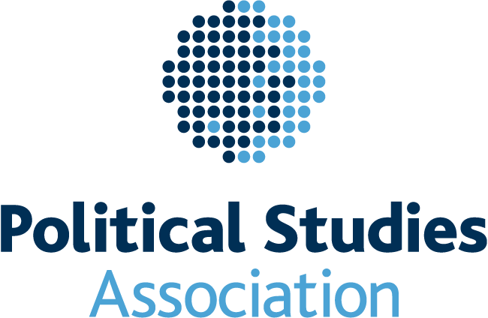

Political Studies Association - policy and guidance on the use of social media

Introduction

This document sets out the expectations of the PSA regarding its members’ usage of social media, particularly in relation to PSA accounts. All references to members here include PSA employees.

The PSA recognises and supports the benefits that the use of social media can bring to our field. For the purposes of this policy, social media is defined as a type of interactive online media or application that allows parties to communicate instantly with each other or to share data in a public forum. This includes online social forums, anonymous apps, blogs, video-and image-sharing apps and websites and similar facilities. It can be used to share information, to keep users up to date with important developments and promote healthy academic debate about controversial subjects and areas of research.

There is, however, an inherent risk involved in using social media as it is an immediate and far reaching form of communication and inappropriate use therefore has the potential for damaging impacts on our members, our Association and our field as a whole.

While the PSA encourages its members to engage, collaborate and innovate through social media, they must also be aware of the potential impact on others and on the PSA itself.

Who does this apply to?

This policy relates to all PSA members in relation to the creation of or contributions to any of the social media described above. It should be applied to all use and all forms of social media where there is potential impact on the PSA, whether related to the operational effectiveness of the organisation; the achievement of its strategic objectives; or to the wider reputation of the PSA.

Those in a position of responsibility who might be seen as representing the PSA or its views on certain issues should be particularly mindful of their use of social media in that capacity. This expectation applies to PSA staff; trustees; appointed officers of PSA networks; and convenors of specialist groups. All members should be aware that statements made on personal accounts which identify the individual’s membership of or affiliation to the PSA, or which make reference to any aspect of PSA business, are covered by this policy. It is recommended that members use a general disclaimer in relation to any PSA affiliation such as ‘all views expressed are in a personal capacity and do not reflect the views of the PSA.’

General guidance

- Members should never represent the PSA in a false or misleading way. All statements regarding or pertinent to the PSA must not be misleading; all claims must be substantiated.
- Members should apply the same standards of conduct online as they would be expected to adhere to in any other context.
- Social networking platforms are in the public domain and it is not always possible to be sure what is being viewed, shared or archived, even if material is posted on a closed profile or group. There can be no reasonable expectation that posts will remain private and will not be passed on to other people, intentionally or otherwise. Material published online may have the potential to be available publicly and indefinitely.
- Inappropriate behaviour via social media may constitute harassment and bullying and may therefore fall under the PSA’s anti-harassment policy. In such cases members may be subject to the reporting, investigatory and disciplinary procedures set out in that policy.

Possible action

- The PSA may occasionally require members to remove social media postings which are deemed to constitute a breach of this policy and failure to comply with such a request may lead to disciplinary action.
- Activities which are in breach of this policy or which, in the opinion of the PSA Executive Committee, may bring the PSA into disrepute may be subject to investigation and disciplinary action. Such action will be proportionate to the nature of the offence and may include a written warning; temporary or permanent loss of position (where the perpetrator is a PSA office holder); or temporary or permanent loss of membership. These possible actions regarding membership are outlined in the PSA’s bye-laws.

Statement on political impartiality and standing for elected office

Many PSA members will also be members of political parties and will take part in campaigning or standing for election to public office. They will therefore also take up positions as elected members in local or national governments. Members should be mindful that the PSA is a politically neutral organisation which will not endorse particular parties or candidates. As such, in the event that members are seeking public office, they should not draw undue attention to their PSA membership or, if applicable, any officer/leadership role e.g. through their personal twitter or facebook profiles, or use this to support their campaign or suitability for office. Any abuse of the PSA social media policy in relation to political campaigning or in the conduct of public office may also be subject to disciplinary proceedings.

